## Intel® RealSense™ D400 Series Depth Camera

**What do we have**

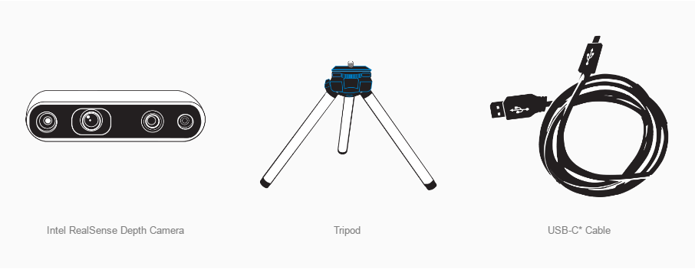 **Intel RealSense Depth Camera**

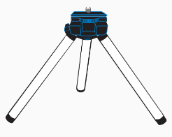 **Tripod**

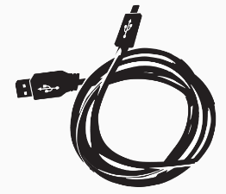 **USB-C* Cable**

### Software: Intel RealSense viewer

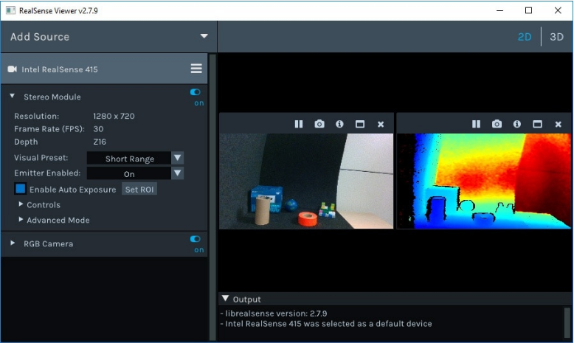

### By using the Intel RealSense viewer , we can get a RGB stream and a depth stream side by side. Besides, we can use the software to get the depth of the staffs and set the visual preset to control the range. There’s also a toggle between 2D to 3D to see the 3D point cloud.

**What can we do with it?**

**By using the camera, we can get the 3D location of the stuffs in a particular area, so that we can enable the robotics arm get the right location to claw the stuff. We can also use the RGB stream to devide stuffs into diffferent classification by get the characters of the picture.**